Rotate a set Deals using aaBridge – a How to

Compiled by Roger Pfister http://RogerPf.com/aaBridge

You already have a set of deals that you have collected

Your hands will now be in a .lin file (possibly you got them my merging a number of files downloaded from BBO, by using http://www.bridgebase.com/myhands/index.php )

Also please look in the aaBridge Document Collection BUILT INTO aaBridge and see
Enter (Type) Hands into aaBridge – a How to

NOTE – The process below is designed to REMOVE all bidding and play (so be ready for BBO upload).
PLEASE refer to the SCREEN SHOT on the NEXT page
Open your existing lin file in aaBridge (drag and drop it on to aaBridge)
example.lin is an example lin file
Raise the lower divider bar and

Click (very LOWER LEFT) the button RED 1 called
Save Deals As .pbn (this is where all the bidding and play are removed)
a new .bpn file will be created next to your example.lin file. It will be called
yyz__pbn_from___example.lin___.pbn
for your sanity rename this to ...
example.pbn (you must keep the .pbn ending)
drag and drop this pbn file into aaBridge
now go through all the three radio buttons RED 3
after clicking each radio button then click the pbn file RED 2 THEN click the next of the radio buttons
(FYI - RED 2 reloads the .pbn and automatically makes the .lin file, rotated as selected by RED3)
The three files you want are the ones shown at the top of the next page with the long names like
yyy_lin_from_example__90_rotation.lin

90_rotation means that each successive hand is rotated. So NSEW all get a chance to be in the hot seat.
If you want to use the hands on a partnership bidding table then just use 180_rotation.
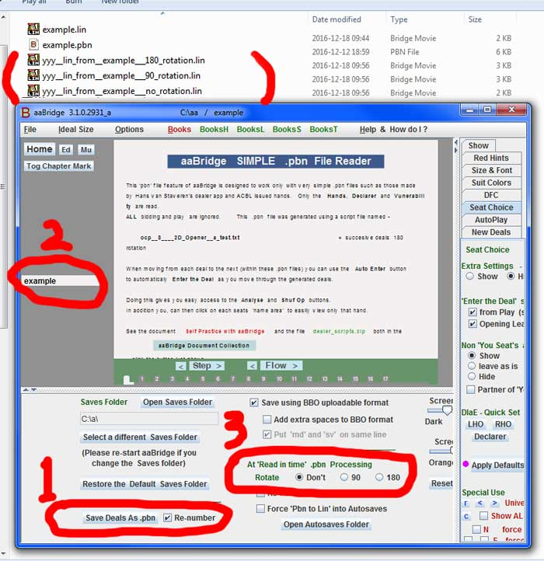

NOTE The aaBridge dealer package from the aaBridge Doc Collection will generate .pbn files from the supplied dealer scripts.

<end of document>

